Check data, like hide data displayed to run this script , 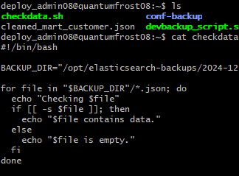

#!/bin/bash

BACKUP_DIR="/opt/elasticsearch-backups/2024-12-27"

for file in "$BACKUP_DIR"/*.json; do
echo "Checking $file"
if [[ -s $file ]]; then
echo "$file contains data."
else
echo "$file is empty."
fi
done

